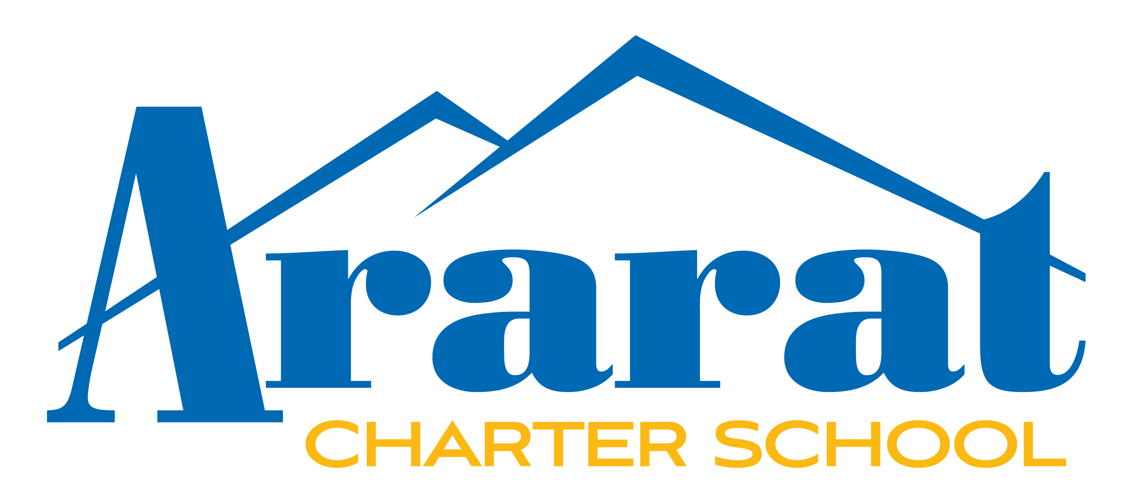
AGENDA

GOVERNING BOARD MEETING
ARARAT CHARTER SCHOOL

October 7, 2021
6:30 pm

Special Meeting

Ararat Charter School is inviting you to a scheduled Zoom meeting.

Topic: Governing Board Meeting – Special
Time: Oct 7, 2021, 06:30 PM Pacific Time (US and Canada)

Join Zoom Meeting
https://us06web.zoom.us/j/81686443647

Meeting ID: 816 8644 3647

One tap mobile
+12532158782,,81686443647# US (Tacoma)
+13462487799,,81686443647# US (Houston)

Dial by your location
+1 253 215 8782 US (Tacoma)
+1 346 248 7799 US (Houston)
+1 720 707 2699 US (Denver)
+1 301 715 8592 US (Washington DC)
+1 312 626 6799 US (Chicago)
+1 646 558 8656 US (New York)

Meeting ID: 816 8644 3647

Find your local number: https://us06web.zoom.us/u/kdds9KZdtZ

Members of the public who wish to comment during the Board meeting may use the “raise hand” tool on the Zoom platform. Individual comments will be limited to three (3) minutes. If an interpreter is needed for comments, they will be translated to English and the time limit shall be six (6) minutes. The Governing Board may limit the total time for public comment to a reasonable time.

The Board reserves the right to mute or remove a member of the public if comments or actions disrupts the Board meeting.

Access to Board Materials: A copy of the written materials which will be submitted to the School’s Governing Board may be reviewed by any interested persons on Ararat Charter School’s website along with this agenda following the posting of the agenda at least 72 hours in advance of this meeting.

Disability Access: Requests for disability-related modifications or accommodations to participate in this public meeting should be made 24 hours prior to the meeting by calling (818) 994-2904 or cmenjivar@araratcharterschool.com. All efforts will be made for reasonable accommodations. The agenda and public documents can be modified upon request as required by Section 202 of the Americans with Disabilities Act.

Instructions for Presentations to The Board by Parents and Citizens

The Ararat Charter School (“School”) welcomes your participation at the School’s Board meetings. The purpose of a public meeting of the Governing Board (“Board”) is to conduct the affairs of the School in public. We are pleased that you are in attendance and hope that you will visit these meetings often. Your participation assures us of continuing community interest in our School. To assist you in the ease of speaking/participating in our meetings, the following guidelines are provided.

- Agendas and all relevant documents are available to all audience members at the meeting.

- “Request to Speak” forms are available to all audience members who wish to speak on any agenda or non-agenda items.

- “Oral Communications” is set aside for members of the audience to raise issues that are not specifically on the agenda. However, due to public meeting laws, the Board can only listen to your issue, not respond or take action. These presentations are limited to three (3) minutes and total time allotted to non-agenda items. The Board may give direction to staff to respond to your concern or you may be offered the option of returning with a citizen-requested item.

- With regard to items that are on the agenda, you may specify that agenda item on your “Request to Address the Board” form and you will be given an opportunity to speak for up to three (3) minutes when the Board discusses that item.

- When addressing the Board, speakers are requested to state their name and address and adhere to the time limits set forth.

- Citizens may request that a topic related to school business be placed on a future agenda. Once such an item is properly agendized and publicly noticed, the Board can respond, interact, and act upon the item.

- OPEN SESSION

- Call to Order
- Roll Call

- GOVERNING BOARD FINDINGS PURSUANT TO GOVERNMENT CODE SECTION 54953(e)

The Charter School Governing Board determines, in accordance with Government Code Section 54953(e)(1)(B), that meeting in person would present imminent risks to the health or safety of attendees. Pursuant to Government Code Section 54953(e)(3), the Board has also reconsidered the circumstances of the State of Emergency declared by the Governor on March 4, 2020, and finds the State of Emergency continues to directly impact the ability of the Directors to meet safely in person and/or that State or local officials continue to impose or recommend measures to promote social distancing.

- APPROVAL OF MINUTES OF BOARD MEETING OF SEPTEMBER 16, 2021

- APPROVAL OF CHECK AND CREDIT CARD REGISTERS

- COMMUNICATIONS

  - Oral Communications:
Non-agenda items: no individual presentation shall be for more than three (3) minutes and the total time for this purpose shall not exceed fifteen (15) minutes. Ordinarily, Board members will not respond to presentations and no action can be taken. However, the Board may give direction to staff following a presentation

  - Principal’s Report
This is a presentation of information that has occurred since the previous Board meeting. (Per attached report)

  - Director of Operation’s Report
This is a presentation of information that has occurred since the previous Board meeting. (Per attached report)

  - Financial Report
This is an update from what has transpired since the last board meeting. (Per attached report)

- DISCUSSION, INFORMATION, AND POSSIBLE ACTION ITEMS
After the presentations, the Board will consider which items will be removed from the list of "consent" items which will be adopted with a single vote without discussion. This is followed by the Board discussing and voting on the items removed from the list by the Board or where individuals have signed up to address the Board on the item.

- Update on Facility Purchase
- Update on Material Revision to Charter Petition and Facilities’ Plan
- Update on Allstate Custodial Services
- Introduction of Governing Board Member Nominees

- CLOSED SESSION

Adjourned to Closed Session to consider and/or take action upon any of the following items:
Public Employee Employment (G.C. 54957)

Title:
    - Conference with Legal Counsel
    - Pupil Discipline
    - Appointment, Employment, Evaluation and Discipline of Personnel
    - Real Estate Negotiations
    - Public Security

- PUBLIC SESSION – REPORT OUT OF CLOSED SESSION
The Governing Board will report out any action taken in closed session, if any

- ACTION ITEMS/CONSENT AGENDA ITEMS
After the presentations, the Board has considered which items to be removed from the list of "consent" items which will be adopted with a single vote without discussion. This is followed by the Board discussing and voting on the items removed from the list by the Board or where individuals have signed up to address the Board on the item.

  - Approval is Requested for Material Revision’s Revised Facilities Plan
  - Approval is Requested for Allstate Amended Contract
  - Approval is Requested Governing Board Member Nominees Appointment

- FUTURE AGENDA ITEMS
The Board will discuss items for future Board meeting agendas

- NEXT BOARD MEETING DATE
November 18, 2021, 6:30pm

- ADJOURNMENT

